4-1.Buzzer
1.Preparation
1.You should learn about the position of the buzzer in the body of hellobot；
3.You should learn about the micro:bit pins connected to the buzzer in the schematic.
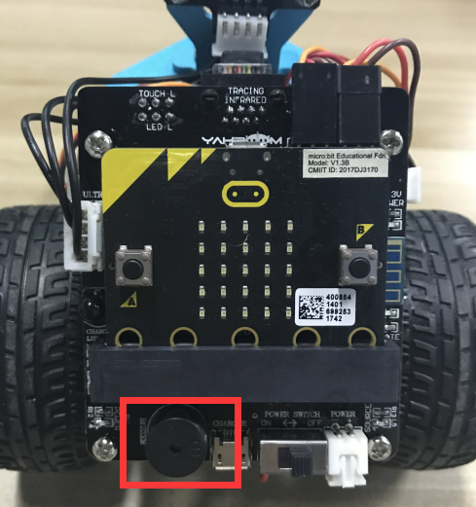
4-1-1 buzzer on arm of hellobot
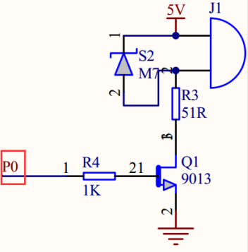
4-1-2 schematic
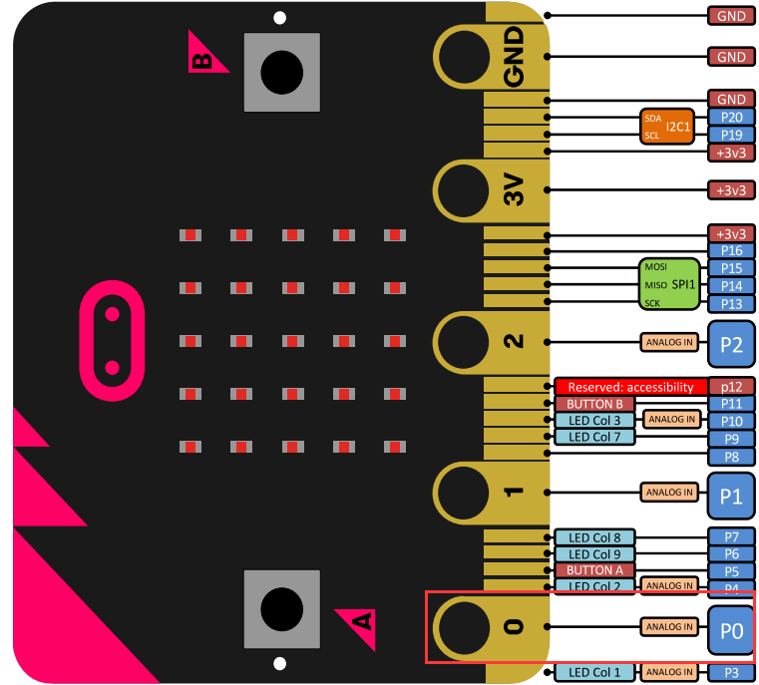
4-1-3 Pins of Micro:bit
From the schematic diagram in 4-1-3, you can see that the touch magic lights is connected to the P0 of the Micro:bit. You can use the blocks of music directly.
- Learning goals
In this course, we will study how to make HelloBot robot sing “Happy Birthday”
3.Programming
3.1 Programming online
You can enter the URL directly in your browser: http://python.microbit.org/v/1 to enter programming online interface.
3.2 Programming offline
1) You can double-click to use it. As shown in the following figure.
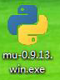
2) After entering the programming interface.

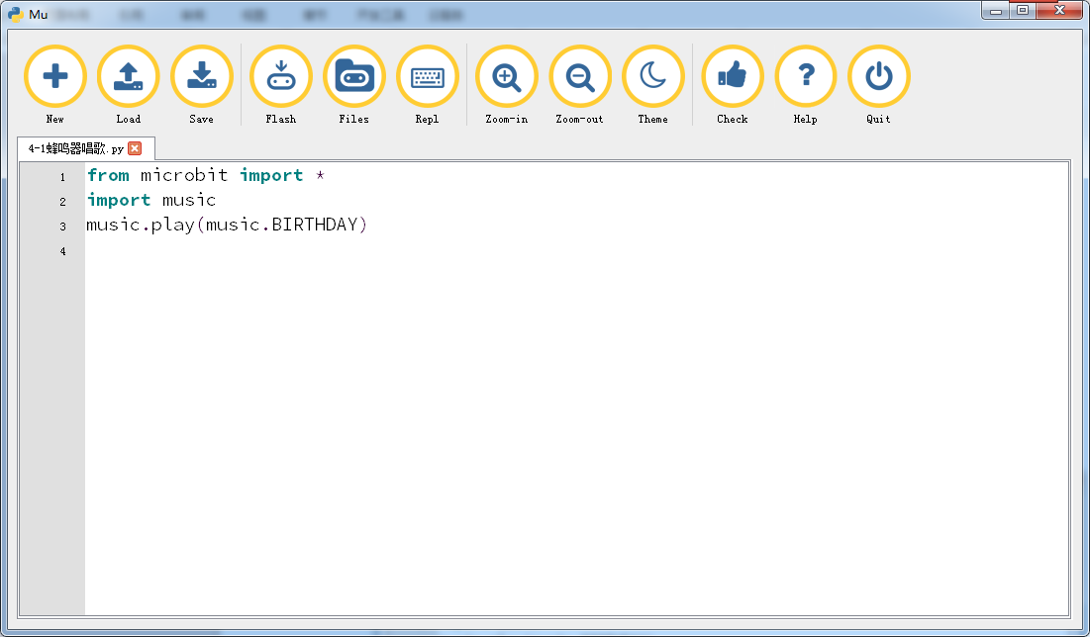
4-1-3
Note:
1 - The capital letter / lowercase letters must be distinguished！
2 - Correct spelling!
3 - Keywords such as # need a space between the content.
4 - The program ends with a blank program.
5 - The block body (such as the body of the while is marked by indentation), compared to the C language, Python completely eliminates the braces (along with the semicolon of the suffix), and uses the indentation structure to represent the relationship. You can only use the Tab key (tabulation key) for indentation.

4.Download programming
You need to make sure that the micro:bit development board is connected to the computer and you need to click “Flash” button.
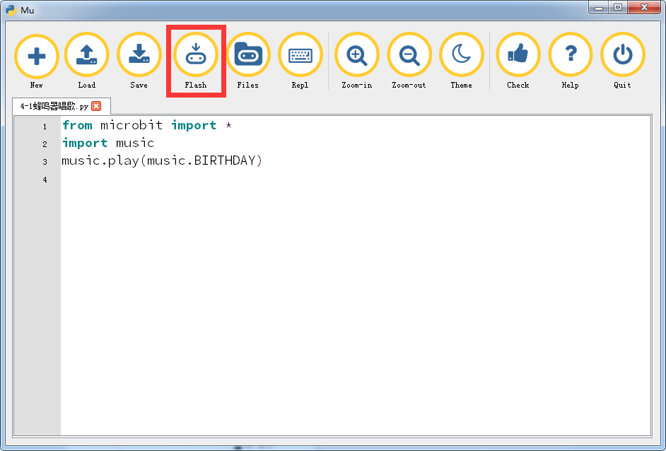
4-1-5
5.Phenomenon
After the code is uploaded. HelloBot robot will sing “Happy Birthday”.

